Create an infographic illustrating the Domain Driven Design (DDQ) process. Highlight steps within it and a real world use case

The Domain-Driven Design (DDD) Process Steps
DDD is a software development approach that focuses on mastering the complexity of a business domain by connecting the implementation to an evolving model of that core area. It follows a continuous, iterative cycle:

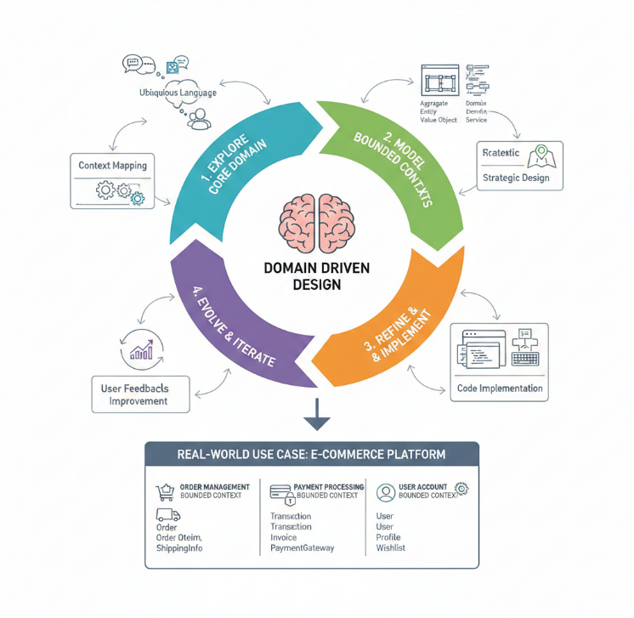
1. Explore Core Domain
This is the foundational step where the team gains a deep understanding of the business problem and aligns the terminology.
- Ubiquitous Language (UL):
  - This is the shared, precise vocabulary used by both domain experts (business stakeholders) and developers.
  - It ensures clear communication and consistency, as the terms used in discussions must match the terms used in the code.
  - Example: If the business calls a product return an "RMA," the code and documentation must also use "RMA."
- Context Mapping:
  - This defines the relationships between the different parts (subsystems) of the larger system.
  - It helps delineate where one set of terms (one UL) ends and another begins.
2. Model Bounded Contexts
In this phase, the system is logically divided into smaller, self-contained, and independent units.
- Bounded Context:
  - This is a defined boundary within which a specific domain model and its Ubiquitous Language are valid and consistent.
  - It encapsulates the model, ensuring that changes within one context do not inadvertently break another.
- Domain Model Elements (Tactical Design):
  - Aggregate: A cluster of associated objects (Entities and Value Objects) that are treated as a single unit for data changes. It is accessed only through its Root Entity.
  - Entity: An object distinguished by its identity (ID) that remains constant over time (e.g., Customer, Order).
  - Value Object: An object that describes some characteristic but has no conceptual identity; it is defined only by its attribute values (e.g., Money, Address).
  - Domain Service: Logic that does not naturally fit into an Entity or Value Object (e.g., calculating shipping fees).
- Strategic Design:
  - This involves classifying the Bounded Contexts (e.g., as Core Domain, Supporting Subdomain, or Generic Subdomain) to prioritize development efforts.
3. Refine & Implement
This step involves translating the carefully constructed domain model into working code.
- Code Implementation:
  - The principles of the tactical design (Aggregates, Repositories, Entities) are directly applied in the code structure.
  - The structure of the code is a direct reflection of the business model within its Bounded Context.
4. Evolve & Iterate
DDD is a continuous process; the model is never final.
- User Feedbacks Improvement:
  - The system is deployed, user feedback is collected, and the model and code are continuously revised based on new business requirements and deeper understanding.
  - This forms a loop where the understanding of the domain constantly improves, leading to better software.
Real-World Use Case: E-Commerce Platform
A complex E-Commerce Platform can be effectively managed by splitting it into distinct Bounded Contexts using DDD principles:
Bounded Context | Core Responsibility | Key Domain Objects
Order Management | Handling the placing, tracking, and fulfillment of customer orders. | Order, Order Item, Shipping Info
Payment Processing | Managing all financial transactions, including charging and refunding customers. | Transaction, Invoice, Payment Gateway
User Account | Managing customer profiles, authentication, and personal settings. | User, Profile, Wishlist
Inventory/Catalog | Maintaining product information, stock levels, and pricing. | Product, Stock, Price

